CLUB FELINO DEL CANTABRICO ES-0324
 | QUEEN | STUD
Cat’s complete registered name
Registration No.

Breed and colour

Owner’s name

Owner’s address
Phone:
Email:

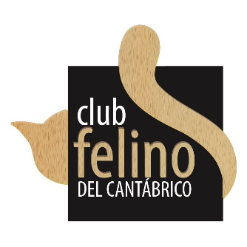  Date of Mating: Expected Date of Birth: | Signature of Stud’s Owner:
CERTIFIED PEDIGREE OF MALE TO BE ATTACHED!!

